Acuity Research and Practice logo.
 
This includes the tagline, 'Intelligence. Insight. Improvement' below the word 'Acuity', and three i's and a full stop in the shape of a triangle to the right. 

**Tenant Satisfaction Measures – Summary of Approach 2024/25**

**Cornwall Housing**

**Table of Contents**

Introduction 3

Summary of Achieved Sample & Sample Method 3

Timing of Survey 4

Collection Method(s) 4

Sample Method 4

Representativeness 5

Questionnaire 8

## **Introduction**

The Tenant Satisfaction Measures (TSM) Standard mandates that all registered providers develop and report TSMs in accordance with the guidelines set by the Regulator. As part of this requirement, it is necessary for Cornwall Housing to inform its customers about its approach to conducting the TSM Perception survey and collecting data.

This document details Cornwall Housings methodology and outlines the criteria specified in the Regulator of Social Housing’s publication, Tenant Satisfaction Measures Return.

The Tenant Satisfaction Measures (TSM) Standard requires all registered providers to conduct tenant perception surveys and report performance annually as specified by the RSH. TSMs are intended to make landlords’ performance more visible to tenants so that tenants can hold their landlord to account. TSMs consist of 22 measures: 10 providing management information from data held by the landlord and 12 satisfaction measures gathered from tenant surveys. In addition to overall satisfaction with landlord services, the measures cover five key themes:

* Keeping properties in good repair
* Maintaining building safety
* Respectful and helpful engagement
* Responsible neighbourhood management
* Effective handling of complaints

Providers must publish a summary of the survey approach used to generate published tenant perception measures. This must be made clearly available alongside each set of tenant perception measures published by the provider.

## **Summary of Achieved Sample & Sample Method**

Cornwall Housing works with Acuity Research & Practice Ltd, an accredited organisation that is dedicated to providing research services in the social housing sector. We use survey information to understand how our tenants feel about their homes and services, and how we can improve. Acuity was commissioned for collecting, generating and validating reported perception measures.

In 2024/25, Cornwall Housing completed TSM surveys with a sample of residents. The sample size was chosen to ensure that the level of statistical accuracy set out by the Regulator of Social Housing was met. Cornwall Housing must ensure that it survey enough residents to meet a statistical accuracy (margin of error at 95% confidence interval) of +/- 3%.

During 2024/25, Cornwall Housing completed 1,037 TSM surveys. Cornwall Housing has 10,301 properties which means that a statistical accuracy level of +/- 2.9% was achieved, which is a greater level of accuracy than required.

No tenant was removed from the sample frame.

An incentive of £100 voucher for one prize draw winner was offered each quarter.

## **Timing of Survey**

Cornwall Housing carried out a total of 1,037 surveys between 2 April 2024 and 18 March 2025.



## **Collection Method(s)**



The TSM Surveys were completed via telephone interview, although tenants were given the option to complete the survey online if they wished, although only one tenant did so. The rationale for using a mixed methodology approach is:

* **Accessibility and Inclusivity**: Ensuring accessibility for all tenants, which aligns with our goal of reaching a broad and representative sample.
* **Engagement and Data Quality**: Indirect interaction online, and direct interaction over the phone tends to enhance engagement, allowing participants to answer clarifying questions and leading to more accurate and detailed responses. This is particularly valuable for nuanced satisfaction metrics.
* **Response Rates**: Using a mixed method approach maximises the robustness of our data and ensuring the results truly reflect the tenant base. Continuing to include a telephone aspect also allows Cornwall Housing to be reactive to flags and alerts, which improves customer recovery.
* **Reliability and Consistency**: Maintaining consistency with previous years' methodologies allows for more reliable trend analysis. It also enables richer information to be gathered.
* **Independence**: Using Acuity, an independent market research agency, means that participants are free from influence from the rest of the organisation.

## **Sample Method**

Acuity contacted a random selection of current tenants to participate in a monthly telephone survey based on quotas set on tenure, area and age. All tenants had the opportunity to complete the survey online by either requesting to do so when speaking to an interviewer. The survey is carefully scripted to ensure a professional and consistent process.

Survey responses are immediately shared with Cornwall Housing, who then manage a follow-up and review process which includes both responding to feedback as necessary and analysing the feedback to understand how we can improve.

## **Representativeness**

Representative checks were carried out to ensure that the survey was representative of the tenant population as a whole. The characteristics by which representativeness was determined were:

|  |  |  |
| --- | --- | --- |
| **Housing Stream** | **Population** | **Sample** |
| General Needs | 76% | 81% |
| Housing for Older People | 24% | 18% |
| Supported | 0% | 0% |

|  |  |  |
| --- | --- | --- |
| **Sub Area** | **Population** | **Sample** |
| Area 1 | 3% | 3% |
| Area 10 | 0% | 0% |
| Area 11 | 3% | 3% |
| Area 12 | 4% | 3% |
| Area 13 | 9% | 10% |
| Area 14 | 1% | 1% |
| Area 15 | 1% | 1% |
| Area 16 | 0% | 0% |
| Area 17 | 1% | 0% |
| Area 18 | 1% | 1% |
| Area 19 | 2% | 2% |
| Area 2 | 1% | 1% |
| Area 20 | 3% | 3% |
| Area 21 | 2% | 2% |
| Area 22 | 6% | 5% |
| Area 23 | 1% | 1% |
| Area 24 | 3% | 3% |
| Area 25 | 1% | 1% |
| Area 26 | 1% | 1% |
| Area 27 | 7% | 6% |
| Area 28 | 5% | 5% |
| Area 29 | 3% | 3% |
| Area 3 | 3% | 3% |
| Area 30 | 2% | 2% |
| Area 31 | 11% | 10% |
| Area 32 | 1% | 1% |
| Area 33 | 0% | 0% |
| Area 34 | 0% | 1% |
| Area 35 | 2% | 2% |
| Area 36 | 3% | 3% |
| Area 37 | 10% | 10% |
| Area 38 | 2% | 3% |
| Area 39 | 0% | 0% |
| Area 4 | 0% | 0% |
| Area 5 | 5% | 4% |
| Area 6 | 1% | 1% |
| Area 7 | 1% | 1% |
| Area 8 | 0% | 0% |
| Area 9 | 0% | 0% |

|  |  |  |
| --- | --- | --- |
| **No. of bedrooms** | **Population** | **Sample** |
| 1 | 12% | 31% |
| 2 | 39% | 40% |
| 3 | 46% | 22% |
| 4 | 3% | 1% |

|  |  |  |
| --- | --- | --- |
| **Ethnicity** | **Population** | **Sample** |
| Black British - Other | 0% | 0% |
| Cornish | 7% | 5% |
| Other Ethnic Group | 0% | 0% |
| White British | 89% | 75% |
| White Irish | 0% | 0% |
| White Other | 2% | 2% |
| Refused | 0% | 0% |

|  |  |  |
| --- | --- | --- |
| **Property Type** | **Population** | **Sample** |
| Bedsit | 1% | 0% |
| Bungalow | 22% | 25% |
| Flat | 29% | 28% |
| House | 48% | 46% |
| Maisonette | 1% | 0% |
| **Age Group** | **Population** | **Sample** |
| 0 - 24 | 2% | 1% |
| 25 - 34 | 9% | 11% |
| 35 - 44 | 16% | 16% |
| 45 - 54 | 17% | 17% |
| 55 - 59 | 10% | 10% |
| 60 - 64 | 10% | 10% |
| 65 - 74 | 17% | 16% |
| 75 - 84 | 14% | 13% |
| 85 + | 6% | 5% |

## **Questionnaire & Introductory Text**

 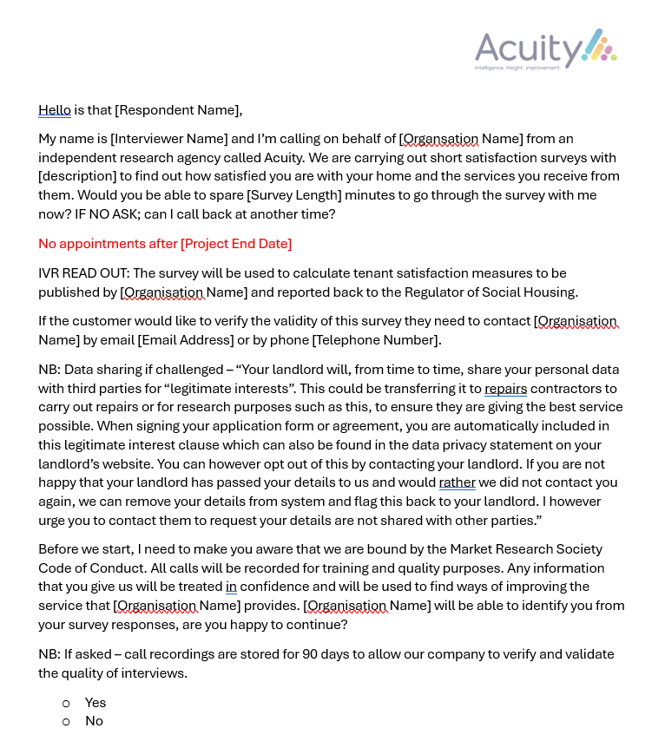

|  |  |  |
| --- | --- | --- |
| **Label** | **Question text** | **Rating scale** |
| Overall Satisfaction | Taking everything into account, how satisfied or dissatisfied are you with the service provided by Cornwall Housing? | Very satisfied, Fairly satisfied, Neither satisfied nor dissatisfied, Fairly dissatisfied, Very dissatisfied |
| Overall Satisfaction Comments (TP01) | Please describe your specific experiences that have shaped your view of your landlord's service. | Open Ended |
| Well Maintained Home | How satisfied or dissatisfied are you that Cornwall Housing provides a home that is well maintained? | Very satisfied, Fairly satisfied, Neither satisfied nor dissatisfied, Fairly dissatisfied, Very dissatisfied |
| Safe Home | Thinking about the condition of the property or building you live in, how satisfied or dissatisfied are you that Cornwall Housing provides a home that is safe? | Very satisfied, Fairly satisfied, Neither satisfied nor dissatisfied, Fairly dissatisfied, Very dissatisfied, Not applicable / Don't know |
| Well Maintained & Safe Comments (deleted in Q1 25/26) | If you are dissatisfied with how your home is maintained and/or that your home is safe, please can you tell us why? | Open Ended |
| Communal Areas? | Do you live in a building with communal areas, either inside or outside, that Cornwall Housing is responsible for maintaining? | Yes, No, Don't Know |
| Communal Area satisfaction | How satisfied or dissatisfied are you that Cornwall Housing keeps these communal areas clean and well-maintained? | Very satisfied, Fairly satisfied, Neither satisfied nor dissatisfied, Fairly dissatisfied, Very dissatisfied |
| Home or communal areas safe or well maintained Comments | Share your views on the safety and maintenance of your home and communal areas. | Open Ended |
| Contribution to neighbourhood (TP11) | How satisfied or dissatisfied are you that Cornwall Housing makes a positive contribution to your neighbourhood? | Very satisfied, Fairly satisfied, Neither satisfied nor dissatisfied, Fairly dissatisfied, Very dissatisfied, Not applicable / Don't know |
| Neighbourhood Contribution Comments | Share your views on your landlord's contribution to your neighbourhood. | Open Ended |
| Approach to ASB (TP12) | How satisfied or dissatisfied are you with Cornwall Housing's approach to handling anti-social behaviour? | Very satisfied, Fairly satisfied, Neither satisfied nor dissatisfied, Fairly dissatisfied, Very dissatisfied, Not applicable / Don't know |
| ASB Comments | Tell us your thoughts on your landlord's approach to handling anti-social behaviour? | Open Ended |
| Repairs in last 12 months? | Has Cornwall Housing carried out a repair to your home in the last 12 months? | Yes/No |
| Repairs last 12 months satisfaction | How satisfied or dissatisfied are you with the overall repairs service from Cornwall Housing over the last 12 months? | Very satisfied, Fairly satisfied, Neither satisfied nor dissatisfied, Fairly dissatisfied, Very dissatisfied |
| Time taken repairs | How satisfied or dissatisfied are you with the time taken to complete your most recent repair after you reported it? | Very satisfied, Fairly satisfied, Neither satisfied nor dissatisfied, Fairly dissatisfied, Very dissatisfied |
| Repairs Service and/or Time Taken Comments (deleted in Q1 25/26) | Please can you tell us why you are dissatisfied with the repairs service and/or the time taken for your most recent repair? | Open Ended |
| Repairs Service and/or Time Taken Comments (TP2 & TP03) | Please can you tell us why you are dissatisfied with the repairs service and/or the time taken for your most recent repair? | Open Ended |
| Listens to views & acts upon them | How satisfied or dissatisfied are you that Cornwall Housing listens to your views and acts upon them? | Very satisfied, Fairly satisfied, Neither satisfied nor dissatisfied, Fairly dissatisfied, Very dissatisfied, Not applicable / Don't know |
| Keeps you informed | How satisfied or dissatisfied are you that Cornwall Housing keeps you informed about things that matter to you? | Very satisfied, Fairly satisfied, Neither satisfied nor dissatisfied, Fairly dissatisfied, Very dissatisfied, Not applicable / Don't know |
| Listen and Informed Comments | Please can you tell us why you are dissatisfied with your views being listened to and/or being kept informed? | Open Ended |
| Fairly and with respect | To what extent do you agree or disagree with the following `Cornwall Housing treats me fairly and with respect`? | Strongly Agree, Agree, Neither Agree nor Disagree, Disagree, Strongly Disagree, Not Applicable/Don't Know |
| Customer Service and Communication Comments | Describe your experience with the customer service and communications you receive. | Open Ended |
| Fairly and with respect Comments (deleted in Q1 25/26) | Please can you tell us why you don't agree that Cornwall Housing treats you fairly and with respect? | Open Ended |
| Complaints in last 12 months? | Have you made a complaint to Cornwall Housing in the last 12 months? | Yes/No |
| Complaints Handling (TP09) | How satisfied or dissatisfied are you with Cornwall Housing’s approach to complaints handling? | Very satisfied, Fairly satisfied, Neither satisfied nor dissatisfied, Fairly dissatisfied, Very dissatisfied |
| Complaints Comments | Please describe your experience of how complaints are handled. | Open Ended |
| Cost of Living | How concerned are you about the cost of living crisis for you or your household? | Not at all concerned, Slightly concerned, Very concerned, Prefer not to say |
| Easy to Deal With (deleted in Q1 25/26) | How satisfied or dissatisfied are you that Cornwall Housing is easy to deal with? | Very satisfied, Fairly satisfied, Neither satisfied nor dissatisfied, Fairly dissatisfied, Very dissatisfied |
| Easy to deal with Comments - not satisfied (deleted in Q1 25/26) | As you were not satisfied with Cornwall Housing being easy to deal with could you tell me why? | Open Ended |
| NPS (deleted in Q1 25/26) | How likely would you be to recommend Cornwall Housing to other people on a scale of 0 to 10, where 0 is not at all likely and 10 is extremely likely? | 10 - Very likely, 9, 8, 7, 6, 5, 4, 3, 2, 1, 0 - Not very likely at all |
| Permission 1 - Happy to be identified | The results of this survey are confidential. However, would you be happy for us to give your responses to Cornwall Housing with your name attached so that they have better information to help them improve services? | Yes/No |
| Permission 2 - Follow up | Would you be happy for Cornwall Housing to contact you to follow up any of the comments or issues you have raised? | Yes/No |

**Report by Acuity Research & Practice**

01273 287114

acuity@arap.co.uk

01273 287114

01273 287114

01273 287114

01273 287114

acuity@arap.co.uk

acuity@arap.co.uk

01273 287114

www.arap.co.uk