Summary of our approach to achieve the Tenant Satisfaction Measures
What are Tenant Satisfaction Measures?
The Regulator of Social Housing requires all social rent landlords to provide them with performance information every year. The required information is called the Tenant Satisfaction Measures (TSMs), and the Regulator provides detailed guidance for landlords about how this information is collected and calculated. There are 22 TSMs:
- 10 landlord measures – which we calculate ourselves, and
- 12 tenant survey measures, which are collected and calculated by an independent specialist called Acuity.

The Regulator has coded the 22 TSMs, and we have included this code on the published results to make it easier for you to compare them with other social landlord results.

This report explains our approach to collecting and calculating these measures for the last financial year 2024/2025.
Our tenant survey measures
- Who is included in the satisfaction survey for the TSMs?

  - Cornwall Council has a stock of over 10,000 low-cost rental homes, including just over 50 Cornwall Housing social rent homes, and about 56 affordable rent homes. These have all been included in the pool of tenants to assess the tenant population for the satisfaction survey.

  - The Council owns or leases a range of temporary accommodation. By December 24, an assessment against the Regulator eligibility guidance identified for inclusion 70 homes, with 32 in the pipeline but were not ready for let.

  - The Council and Cornwall Housing only had 70 low-cost home ownership homes (shared ownership) – therefore we have excluded these from the survey sample in line with Regulator guidance.

- Our survey approach for the ‘Your Call’ Tenant Satisfaction Measures

  - We commissioned Acuity Research and Practice to undertake a rolling monthly sample survey, primarily by telephone with the option of an online link via email to be sent to the interviewer. Their role was to collect, generate, and validate reported perception measures. We also asked them to flag any urgent safety concerns directly to us.

  - We asked them to engage at least 1000 tenants in total, who are representative of the whole tenant body on the categories of age, area, and tenure type. This sample method is called ‘Random, stratified with quotas’.

  - In line with regulator guidance, incomplete surveys have been included.

  - All social rent tenants were included in the sample frame, and residents who have requested no surveys were removed from the call base (486).

  - In February 25 we/Acuity randomly selected 2 tenants from our supported accommodation. These were interviewed by specialist staff face to face. Survey responses were provided back to Acuity for inclusion in the overall data.

  - We promoted the ‘Your Call’ TSMs survey on our website, social media and in our magazine. It includes the incentive of entry into a free prize draw for £100 supermarket voucher. This is pulled every three months from the >250 that have participated that quarter. Winners’ photographs are published on the website and in the resident magazine.

  - 1037 tenants took part – 1034 by phone and 1 online and 2 face-to-face. The first survey was on 2 April 2024 and the last survey 18 March 2025.

  - This has provided a margin of error of +/-2.9% at 95% confidence level, meeting the requirement of at least +/- 3%.

  - Our satisfaction results have been calculated using unweighted data, and are rounded to the first decimal place.

- How many tenants took part in the questions with a pre-qualifying question?
Some questions in the TSM’s have a ‘pre-qualifying question’. First a tenant is asked if you have experienced that service recently or if it is applicable. The number of tenants who said yes to the pre-qualifying questions and answered the relevant TSM are as follows:

TSM code | TSM question | Pre-qualifying question | Answered yes
TP02 | Satisfaction with repair | Has Cornwall Housing carried out a repair to your home in the last 12 months? | 666
TP03 | Satisfaction with time taken to do the repair |  | 666
TP09 | Satisfaction with the approach to complaints handling | Have you made a complaint to Cornwall Housing in the last 12 months? | 296
TP10 | Satisfaction that the communal area is clean and well maintained | Do you live in a building with communal areas, either inside or outside, that Cornwall Housing is responsible for maintaining? | 310

- Summary of the assessment of representativeness of the sample against the tenant population
The regulator requires all social landlords to try and achieve a response that is representative of their tenant population. After considering the guidance, we chose to ask Acuity to ensure that the total responses were representative in relation to the age, tenure and area of the tenant population. Below is the detail of the percentage of responses in relation to those categories.
Tenure
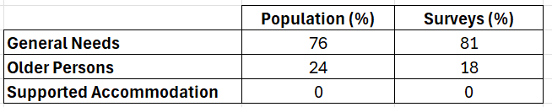

Area (see over)
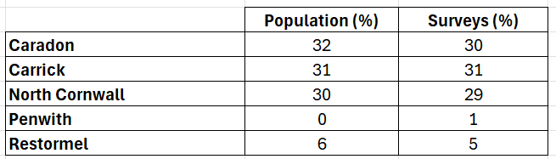

Age
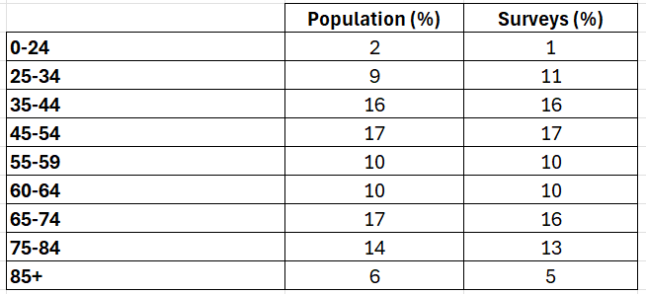

The final results for 2024/25
- Published Results

  - Results were calculated to one decimal place in line with regulatory guidance. Our published results are taken from those calculated from our supplied figures by the regulator’s NROSH system.

For the final published results, please see below:

  - Tenant satisfaction survey
Measure | 2024/25 result
TP01: Overall satisfaction | 69%
TP02: Satisfaction with repairs | 70%
TP03: Satisfaction with time taken to complete most recent repair | 69%
TP04: Satisfaction that home is well maintained | 66%
TP05: Satisfaction that the home is safe | 74%
TP06: Satisfaction that the landlord listens to views and acts upon them | 56%
TP07: Satisfaction that the landlord keeps tenant informed about things that matter to them | 72%
TP08: Agreement that the landlord treats tenant fairly and with respect | 74%
TP09: Satisfaction with the landlord’s approach to handling complaints | 29%
TP10: Satisfaction that the landlord keeps communal areas clean and well maintained | 60%
TP11: Satisfaction that the landlord makes a positive contribution to neighbourhoods | 60%
TP12: Satisfaction with the landlord’s approach to handling anti-social behaviour | 60%

  - Landlord measures
Measure | Subcategory | 2024/25 result
RP01: Homes that do not meet the decent standard | - | 18%
RP02: Repairs completed within target timescale | Non-emergency | 60.68%
 | Emergency | 84.93%
BS01: Gas safety checks | - | 99.88%
BS02: Fire safety checks | - | 100%
BS03: Asbestos safety checks | - | 100%
BS04: Water safety checks | - | 100%
BS05: Lift safety checks | - | 100%
CH01: Complaints relative to the size of the landlord, per 1000 homes | Stage 1 | 102.1
 | Stage 2 | 21.2
CH02: Complaints responded to within Complaint Handling Code timescales | Stage 1 | 73.4%
 | Stage 2 | 79.3%
NM01: Anti-social behaviour cases relative to the size of the landlord, per 1000 homes | All cases | 29.7
 | Hate incidents only | 0.1

TSM Return Provisional Guidance notes 2023 v1 – page 5 completion of parts flowchart

