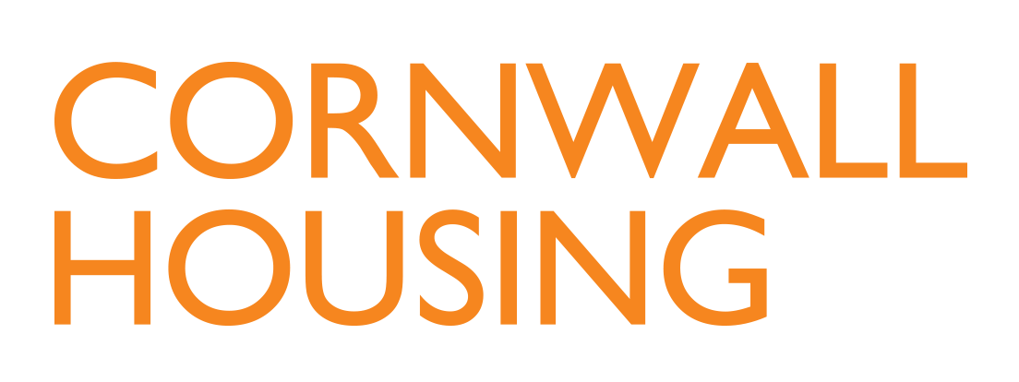

Company number: 04662007

Cornwall Housing Limited (CHL)
Annual General Meeting

Minutes of the Annual General Meeting of Cornwall Housing Limited (the "Company")
held on Monday 21st October 2024 at 13:30hrs at Chy Trevail and via MS Teams.

Members: Robert Stronge (RS) Non-Executive Board Director/Interim SID (Chair)
Kate Atkinson (KA) Non-Executive Board Director
Karen Ayling (KAy) Non-Executive Board Director/Chair of Audit, Finance & Risk
Graham Clarke (GC) Non-Executive Board Director
Rob Dustan (RD) Non-Executive Board Director
Mark Read (MR) Non-Executive Board Director/Service Director, CC
Dawn Sowerby (DS) Non-Executive Board Director/Chair of People & Culture
Amanda Leman (AL) Non-Executive Board Director
Su Spence (SS) Non-Executive Board Director/Managing Director, CHL

Attendees: Peter Marsh (PM) Shareholder Representative/
Service Director - Assets, Capital & Commercial Services, CC
Cllr Oliver Monk (OM) Portfolio Holder (Part Meeting)
Hayley Austin (HA) Executive Director of Housing Operations, CHL
Rachel Smith (RSm) Executive Director of Resources, CHL
Ian Frazer (IF) Executive Director of Asset Management, CHL
Jackie Noyes (JN) Head of Governance, CHL

Apologies: Vivienne Horton (VH) Interim Chair of the Board
Kevin Hawke (KH) Non-Executive Board Director
Louise Wood (LW) Service Director - Planning & Housing, CC

1. | Welcome and Apologies  The Interim Senior Independent Director welcomed everyone to the Cornwall Housing Annual General Meeting 2024.  Apologies were noted as above.
2. | Notice & Quorum  It was NOTED that the Meeting had been duly convened and that the meeting was quorate.
3. | Retirement and Appointment of Board Directors  The Board NOTED that Peter Nourse resigned from the CHL Board as a Non-Executive Director of the Company on 20th April 2024.  The Board NOTED that Mike Hanrahan retired from the CHL Board as Chair/Non-Executive Director of the Company on 30th June 2024.  The Board NOTED the appointment of Graham Clarke as Independent Non-Executive Director on 1st September 2024.  The Board NOTED the appointment of Rob Dustan as Independent Non-Executive Director on 1st September 2024.
4. | Minutes of the Annual General Meeting held on 28th March 2023  The Minutes of the Annual General Meeting 2023 were NOTED.
5. | Review of 2023/24 from the Managing Director  SS shared the 2023/24 Annual Report and made a presentation to the AGM highlighting key achievements from the year and challenges for the future.
6. | To receive the Accounts for the period ended 31st March 2024  The Report and Financial Statements of the Company for the year-ended 31st March 2024 had been circulated with the agenda for review.  It was RESOLVED that the Report and Financial Statements of the Company for the year-ended 31st March 2024 were hereby received by the Board and the Shareholder Representative.
7. | To note that CHL are currently procuring the services of an external auditor and will confirm details once appointed.  The Meeting NOTED the procurement of external auditors.
8. | Shareholder Comments  Peter Marsh was acting as Shareholder for the purposes of the AGM.  Pete expressed thanks to the CHL team on behalf of the Shareholder. He added that the Shareholder had confidence in the Board and Management Team and noted the achievements made. There are many challenges ahead but the focus needs to remain on residents and the services provided for them. PM did want to recognise the good work which has already been done.
9. | Close of the Annual General Meeting

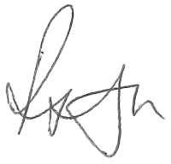
Interim Senior Independent Director

